XB Funding Donor Intelligence Tool

Dashboard Guide

Serena Yin

Table of Contents

Background 2

Dashboard Structure 2

Canada 2

Report: Canada 2

Data Sources 3

Summary Cards 3

Visualizations 3

Filters 4

Report: Canada Permanent Mission 4

Data Sources 5

Summary Cards 5

Visualizations 5

Filters 5

United Arab Emirates 5

Report: United Arab Emirates 6

Data Sources 6

Summary Cards 6

Visualizations 6

Filters 7

Report: UAE Permanent Mission 7

Data Sources 7

Summary Cards 7

Visualizations 8

Filters 8

Qatar 8

Report: Qatar Permanent Mission 8

Data Sources 9

Summary Cards 9

Visualizations 9

Filters 10

UN Digital Library Resolutions 10

Data Sources 10

Summary Cards 11

Visualizations 11

Filters 11

# Background

The DOS-OUSG-PAS team is seeking to enhance its donor intelligence capabilities to better align with member state priorities and improve resource mobilization. Currently, there is a limited understanding of historical funding trends and donor priorities, which hinders strategic engagement. The project aims to address this gap by developing a web-scraping tool to collect and analyze historical contribution data and project funding information from various donor sources. This data-driven approach will support PAS in tailoring its outreach and proposals, identifying emerging donor interests, and aligning funding requests with both DOS strategic goals and Member State donor priorities.

This document will outline how users can navigate the XB Funding Donor Intelligence Dashboard, along with the various views and filters to extract insights from.

For a detailed overview of the overall project methodology and donor intelligence collection process, please refer to the Overview Guide.

# Dashboard Structure

Currently, the dashboard features six different pages. As donor intelligence capabilities grow, the number of report pages in the dashboard will also grow. As of August 2025, the dashboard features the following pages:

* **Canada:** Data from Canada’s International Fund Assistance Projects Website
* **Canada Permanent Mission:** News and Speeches from the Government of Canada’s website
* **United Arab Emirates:** Data from UAE’s Foreign Aid Report published by the Ministry of Foreign Affairs
* **UAE Permanent Mission:** News and Speeches from the UAE Permanent Mission to the UN Website
* **Qatar Permanent Mission:** News and Speeches from the Qatar Permanent Mission to the UN Website
* **UN Digital Library Resolutions:** UN Resolutions and drafts sponsored/co-sponsored by Member States

Please note that for the majority of the stacked bar charts on each report page (with the exception of the “UN Digital Library Resolutions” page), the total showcased in the bar charts is higher than the actual total, as there may be overlap in the categories/ segmentation.

For example, on the “Canada” report page, the “Contribution by Region” bar chart may have higher totals than the overall total contribution if a project was tagged to multiple regions. This would mean that the same project would appear under separate regions/ colors on the bar chart, showcasing how the bar chart may double-count. Additionally, bar charts are limited to the top 7 categories to improve the readability of the visualizations. To get more specific insights past the top 7 categories, please use the filters to the right to drill down the visualizations.

# Canada

There are 2 report pages in the PowerBI dashboard that visualize data relating to Canada and its funding priorities: “Canada” and “Canada Permanent Mission”.

## Report: Canada

The report page titled “Canada” visualizes data from Canada’s International Fund Assistance Projects Website. The website stores data on the international projects Canada funds, including details such as what the project is about, how much money was invested into each project, who the executing agency is etc.

The report page also visualizes the main topic of each UN Resolution that is sponsored/co-sponsored by Canada.

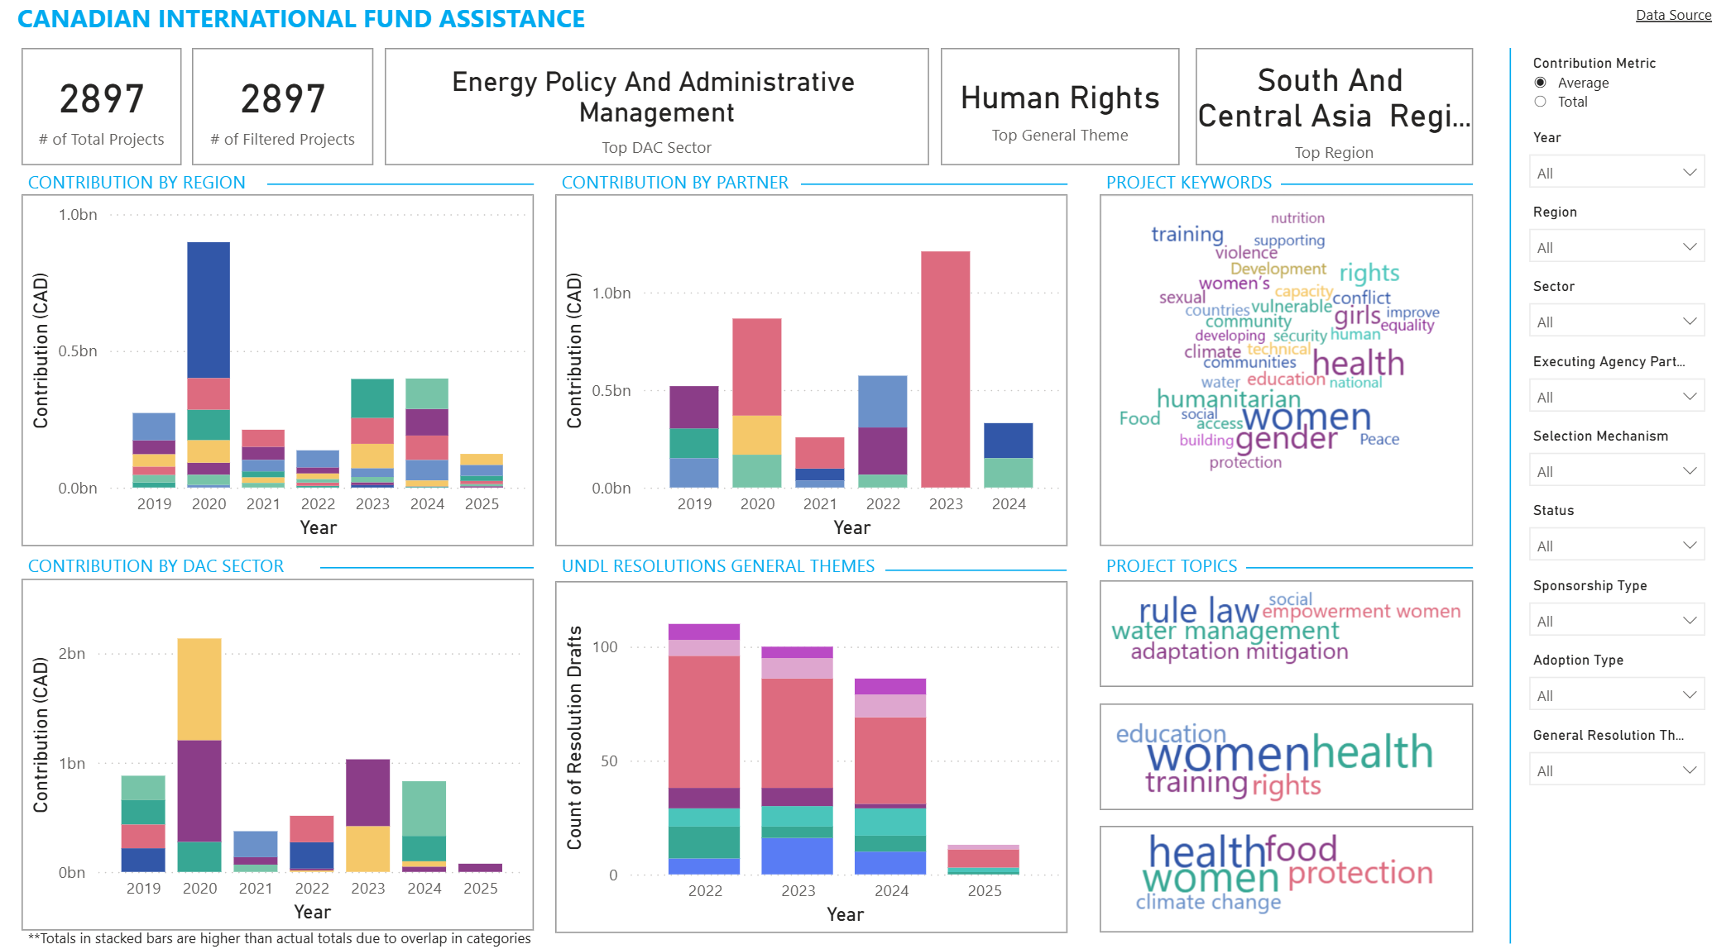

### Data Sources

* [Canadian International Fund Assistance Projects Website](https://w05.international.gc.ca/projectbrowser-banqueprojets/filter-filtre)
* [UN Digital Library (API)](https://digitallibrary.un.org/?ln=en)

### Summary Cards

The summary cards across the top of the page summarize key insights found on the dashboard:

|  |  |
| --- | --- |
| Visualization | Insight |
| # of Total Projects (static) | Total number of projects in the dataset |
| # of Filtered Projects | Number of projects that satisfy the filters applied |
| Top DAC Sector | The DAC Sector with the most contribution |
| Top General Theme | The most frequent theme found in the filtered UN Resolutions |
| Top Region | The Region with the most contributions received |

### Visualizations

Below is an explanation of the different visualizations found on the report page:

|  |  |
| --- | --- |
| Visualization | Explanation |
| Contribution by Region | Contributions made by Canada, separated by Region |
| Contribution by Partner | Contributions made by Canada, separated by the Executing Agency/Partner of the project |
| Project Keywords | Word cloud visualization of keywords from project descriptions, where the size of the word depends on the frequency with which keywords appear in the project descriptions |
| Contribution by DAC Sector | Contributions made by Canada, separated by DAC Sector |
| UNDL Resolutions General Themes | UN Resolutions sponsored/co-sponsored by Canada, separated by themes |
| Project Topics (static) | Top 3 topics from Project Descriptions, derived through LDA Topic Modelling* |

*Please refer to the Overview Guide for more details on how these topics were derived

### Filters

Filters are the primary way to drill down into the visualizations for a more specific view or set of data. The “Canada” report page features the following filters:

|  |  |
| --- | --- |
| Filter | Details |
| Contribution Metric | Toggle between Total Contribution and Average Contribution made to Projects |
| Year | Year of Project Start Date |
| Region | Project Region |
| Sector | Project DAC Sector |
| Executing Agency Partner | Executing Agency Partner of the Project |
| Selection Mechanism | How the Project was Selected |
| Status | Completion Status of the Project |
| Sponsorship Type | Whether Canada Sponsored or Co-Sponsored the UN Resolution Draft |
| Adoption Type | Whether the UN Resolution Draft was adopted or not |
| General Resolution Theme | Themes featured in the UN Resolutions |

## Report: Canada Permanent Mission

The report page titled “Canada Permanent Mission” visualizes news articles and speeches pertaining to the United Nations that are published by the Government of Canada.

### Data Sources

* [Canada and the United Nations – News](https://www.international.gc.ca/world-monde/international_relations-relations_internationales/un-onu/news-nouvelles/index.aspx?lang=eng)
* [Canada and the United Nations – Declarations and Statements](https://www.international.gc.ca/world-monde/international_relations-relations_internationales/un-onu/statements-declarations/index.aspx?lang=eng)

### Summary Cards

The summary cards across the top of the page summarize key insights found on the dashboard:

|  |  |
| --- | --- |
| Visualization | Insight |
| # of Mission News Articles | Number of News Articles that satisfy the filters applied |
| # of Speeches/Statements | Number of Statements that satisfy the filters applied |
| Top News Article Theme | The most frequent theme found in the filtered news articles |
| Top Speeches/Statements Theme | The most frequent theme found in the filtered statements |

### Visualizations

Below is an explanation of the different visualizations found on the report page:

|  |  |
| --- | --- |
| Visualization | Explanation |
| Mission News Articles by Theme | Count of News Articles, separated by Theme |
| Mission News Keywords | Word cloud visualization of keywords from the news articles, where the size of the word depends on the frequency with which keywords appear in the news articles |
| Mission News Topics (static) | Top 3 topics from News Articles, derived through LDA Topic Modelling* |
| Statements by Theme | Count of Statements, separated by Theme |
| Statements Keywords | Word cloud visualization of keywords from the statements, where the size of the word depends on the frequency with which keywords appear in the news articles |
| Statements Topics (static) | Top 3 topics from Statements, derived through LDA Topic Modelling* |

*Please refer to the Overview Guide for more details on how these topics were derived

### Filters

Filters are the primary way to drill down into the visualizations for a more specific view or set of data. The “Canada Permanent Mission” report page features the following filters:

|  |  |
| --- | --- |
| Filter | Details |
| Year | Year in which the news article/statement was published |
| News Article Themes | Themes found in the News Articles |
| Statements Themes | Themes found in the Statements |

# United Arab Emirates

There are 2 report pages in the PowerBI dashboard that visualize data relating to the United Arab Emirates and its funding priorities: “United Arab Emirates” and “UAE Permanent Mission”.

## Report: United Arab Emirates

The report page titled “United Arab Emirates” visualizes data found from the UAE’s Foreign Aid Reports. These reports include information regarding how much aid was given, to which countries, and which funding category.

### Data Sources

* [UAE Ministry of Foreign Affairs Foreign Aid Reports](https://www.mofa.gov.ae/en/The-Ministry/UAE-International-Development-Cooperation/Annual-Foreign-Aid-Report)

### Summary Cards

The summary cards across the top of the page summarize key insights found on the dashboard:

|  |  |
| --- | --- |
| Visualization | Insight |
| Total Overall Contribution (USD) (static) | Total Contribution across all countries, funding categories, and years |
| Total Contribution (USD) | Total Contribution based on filters |
| Top Funding Category | The funding category with the most contributions received |
| Top Country | The country with the most contributions received |

### Visualizations

Below is an explanation of the different visualizations found on the report page:

|  |  |
| --- | --- |
| Visualization | Explanation |
| Contribution by Country | Contribution made by UAE, separated by Country |
| Contribution by Funding Category | Contribution made by UAE, separated by Funding Category |

*Please refer to the Overview Guide for more details on how these topics were derived

### Filters

Filters are the primary way to drill down into the visualizations for a more specific view or set of data. The “Canada Permanent Mission” report page features the following filters:

|  |  |
| --- | --- |
| Filter | Details |
| Contribution Metric | Toggle between Total Contribution and Average Contribution made |
| Year | Year of Foreign Aid |
| Funding Category | Foreign Aid Funding Category |
| Country | Country Receiving Foreign Aid from UAE |

## Report: UAE Permanent Mission

The report page titled “UAE Permanent Mission” visualizes news articles and speeches published by the UAE Permanent Mission to the UN.

### Data Sources

* [UAE Permanent Mission News Articles](https://uaeun.org/?s=&combined-search-post-types=press_release)
* [UAE Permanent Mission Speeches and Statements](https://uaeun.org/?s=&combined-search-post-types=press_release)

### Summary Cards

The summary cards across the top of the page summarize key insights found on the dashboard:

|  |  |
| --- | --- |
| Visualization | Insight |
| # of Mission News Articles | Number of News Articles that satisfy the filters applied |
| # of Speeches/Statements | Number of Statements that satisfy the filters applied |
| Top News Article Theme | The most frequent theme found in the filtered news articles |
| Top Speeches/Statements Theme | The most frequent theme found in the filtered statements |

### Visualizations

Below is an explanation of the different visualizations found on the report page:

|  |  |
| --- | --- |
| Visualization | Explanation |
| Mission News Articles by Theme | Count of News Articles, separated by Theme |
| Mission News Keywords | Word cloud visualization of keywords from the news articles, where the size of the word depends on the frequency with which keywords appear in the news articles |
| Mission News Topics (static) | Top 3 topics from News Articles, derived through LDA Topic Modelling* |
| Statements by Theme | Count of Statements, separated by Theme |
| Statements Keywords | Word cloud visualization of keywords from the statements, where the size of the word depends on the frequency with which keywords appear in the news articles |
| Statements Topics (static) | Top 3 topics from Statements, derived through LDA Topic Modelling* |

*Please refer to the Overview Guide for more details on how these topics were derived

### Filters

Filters are the primary way to drill down into the visualizations for a more specific view or set of data. The “UAE Permanent Mission” report page features the following filters:

|  |  |
| --- | --- |
| Filter | Details |
| Year | Year in which the news article/statement was published |
| News Article Themes | Themes found in the News Articles |
| Statements Themes | Themes found in the Statements |

# Qatar

Since limited data was found on Qatar’s Foreign Aid patterns, only one report page was created to visualize the news articles and speeches found on Qatar’s Permanent Mission to the United Nations Website.

## Report: Qatar Permanent Mission

The report page titled “Qatar Permanent Mission” visualizes news articles and speeches published by the Qatar Permanent Mission to the UN.

### Data Sources

* [Qatar Permanent Mission News Articles](https://ny.mission.qa/en/media/news)
* [Qatar Ministry of Foreign Affairs Statements](https://mofa.gov.qa/en/latest-articles/statements)

### Summary Cards

The summary cards across the top of the page summarize key insights found on the dashboard:

|  |  |
| --- | --- |
| Visualization | Insight |
| # of Mission News Articles | Number of News Articles that satisfy the filters applied |
| # of Speeches/Statements | Number of Statements that satisfy the filters applied |
| Top News Article Theme | The most frequent theme found in the filtered news articles |
| Top Speeches/Statements Theme | The most frequent theme found in the filtered statements |

### Visualizations

Below is an explanation of the different visualizations found on the report page:

|  |  |
| --- | --- |
| Visualization | Explanation |
| Mission News Articles by Theme | Count of News Articles, separated by Theme |
| Mission News Keywords | Word cloud visualization of keywords from the news articles, where the size of the word depends on the frequency with which keywords appear in the news articles |
| Mission News Topics (static) | Top 3 topics from News Articles, derived through LDA Topic Modelling* |
| Statements by Theme | Count of Statements, separated by Theme |
| Statements Keywords | Word cloud visualization of keywords from the statements, where the size of the word depends on the frequency with which keywords appear in the news articles |
| Statements Topics (static) | Top 3 topics from Statements, derived through LDA Topic Modelling* |

*Please refer to the Overview Guide for more details on how these topics were derived

### Filters

Filters are the primary way to drill down into the visualizations for a more specific view or set of data. The “Qatar Permanent Mission” report page features the following filters:

|  |  |
| --- | --- |
| Filter | Details |
| Year | Year in which the news article/statement was published |
| News Article Themes | Themes found in the News Articles |
| Statements Themes | Themes found in the Statements |

# UN Digital Library Resolutions

The dashboard contains a separate report page with the UN Resolutions and Drafts sponsored/co-sponsored by each Member State. The page visualizes the different themes from the resolutions, potentially indicated donor priorities based on what themes each Member State is interested in sponsoring/co-sponsoring.

### Data Sources

* [UN Digital Library (API)](https://digitallibrary.un.org/?ln=en)

### Summary Cards

The summary cards across the top of the page summarize key insights found on the dashboard:

|  |  |
| --- | --- |
| Visualization | Insight |
| # of Resolutions | Number of Resolutions that satisfy the filters applied |
| Top General Theme | The most frequent general theme found in the filtered resolutions |
| Top Specific Theme | The most frequent specific theme found in the filtered news articles |
| Top Member State | Member State with the highest number of filtered resolutions |

### Visualizations

Below is an explanation of the different visualizations found on the report page:

|  |  |
| --- | --- |
| Visualization | Explanation |
| UNDL Resolutions by General Theme | Count of Resolutions, separated by General Theme |
| UNDL Resolutions by Specific Theme | Count of Resolutions, separated by Specific Theme |

*Please refer to the Overview Guide for more details on how these topics were derived

### Filters

Filters are the primary way to drill down into the visualizations for a more specific view or set of data. The “UN Digital Library Resolutions” report page features the following filters:

|  |  |
| --- | --- |
| Filter | Details |
| Year | Year the Resolutions Were Introduced |
| General Theme | General Theme tagged to the resolutions |
| Specific Theme | Specific Theme tagged to the resolutions |
| Sponsorship Type | Whether a Member State sponsored or co-sponsored the resolution |
| Adoption Type | Whether the resolution was adopted |
| Member State | Which Member State sponsored/co-sponsored the resolutions |
| Meeting Body | Where the resolutions were introduced |